Absolute Technologies provides software solutions to facilitate compliance and audit requirements for Oracle based applications.

*"As an existing Absolute customer, we have been very satisfied with their solutions and services. … I am impressed with Application Auditor’s elegant design, ease of use and the simple fact that it works. It only took a few minutes to install, and I had configured and tested several audits within an hour. This solution saved us hundreds of hours and satisfied our auditors at the same time."*

**-** Kenny Gilbert, Director of IT **Silicon Image, Inc.**

**Audit and Compliance**

In 2010 most organizations running Oracle E‑Business Suite have already adjusted to Sarbanes-Oxley legislation (SOX). They have reached a level of compliance that satisfies their auditors. In 2003 – 2007 the initial challenges for Oracle customers included establishing SOX procedures, application change controls, proving that the financial controls in the application environment worked, detection of database activity that circumvented the application-layer controls, and enforcement of segregation of duties (SOD) policies.

Now some Oracle customers want to drive down the cost of compliance through automation. Others are looking to replace the expensive software maintenance fees of their early SOX era commercial applications or to eliminate hard-to-support in-house automation. Some want to streamline the operations, perhaps to eliminate a separate hardware server that runs SOX related software.

Many Oracle customers tell us they want to improve how they implement SOD policies in two areas: application users’ access to conflicting business functions, and IT support staff access to both development and production environments.

Absolute Technologies released **SOD Violations Manager** in 2009 to provide an affordable and effective way for Oracle E-Business Suite customers to implement SOD policies. SOD VM provides capabilities to define conflicts, detect which users have access to conflicting functions, and eliminate the conflicts using E-Business Suite’s built-in features.

**Application Auditor** offers more capabilities for broader compliance requirements and real-time detection of a variety of audit events. This software product is oriented to business, not technical, auditors, for auditing business usage of Oracle Database applications. It is easy to use, has a non-invasive, low risk auditing approach, restricts usage to secure the audit process, can provide flexible audit trail reports, maintains a record of all audit configurations, and facilitates the migration of such configurations across database instances.

**Application Auditor** software can be used in any Oracle Database environment. Two add-on options help E-Business Suite customers by providing additional functionality and seeded rules for auditing configuration, setup, and business transactions, business users, and IT staff activities.

|  |  |
| --- | --- |
| **Application Auditor** | ***Core Product***  Application Auditor for Oracle Database (9i, 10g, 11g) enables end users to capture and report changes to selected data elements in the database by defining and activating audit configurations via online forms. AA can audit DML [record level inserts, updates and deletes] and DDL [create, alter, drop, grant and revoke object] changes, as well as database (DB) logons. By operating at the DB level, AA can automate application and DB level controls. Licensed on a perpetual or annual subscription basis. |
| **SOX Pack** | ***Application Auditor optional module***  Ninety (90) seeded Oracle E-Business Suite (11i, R12) audits for master data, configuration data, and application transactions with financial impact, designed to identify SOX Compliance issues. These are loaded directly into Application Auditor. |
| **E-Business Suite Extensions for SOD** | ***Application Auditor optional module***  These extensions provide additional functionality, and seeded data content, specifically to support both static and dynamic Segregation of Duties controls in E-Business Suite.   * SOD Violations Manager, to define, maintain, and identify Segregation of Duties conflicts associated with Oracle E-Business Suite 11i or R12 user access methods via Responsibilities, Menus, Forms and Functions. * Twelve hundred (1,200) seeded Oracle E-Business Suite function conflicts across 21 modules * Reports for function assignment conflicts and user access menu hierarchies. * User Watch Lists, to define and maintain sets of application users to include or exclude from audit. |
| **SOD Violations Manager** | ***Subscription for Application Auditor Static SOD functionality***  SOD Violations Manager (VM) is packaged as a completely standalone product, and supports static SOD controls in EBS. The same functionality is included in AA within the E-Business Suite Extensions for SOD. Licensed on an annual subscription basis.   * SOD Violations Manager. * Twelve hundred (1,200) seeded Oracle E-Business Suite function conflicts across 21 modules. * Reports for function assignment conflicts and user access menu hierarchies. |

**Product Description**



**Application Auditor** enables Internal Audit and Finance Staff to track and report changes to selected columns of tables in the database by defining audit configurations via online forms.

***Application Auditor***

# Product Summary

**Key Functionality**

* Single, flexible audit mechanism for any column within any table in any Oracle database.
* Easy to use. You can create, configure, and activate an audit trail configuration in minutes.
* Audit trail configuration is by table, so you can record different content in the various tables’ audit trail records.
* Configuration Reports provide a record of all Audit Setups, which facilitates outside auditors’ work.
* Audit trail configurations can send an Email Alert when specified database changes occur.
* Store all audit trail records from multiple database tables in a single audit trail table. This leads to efficient and flexible reporting.
* Each audit trail record can contain:
  + Table and Column name.
  + Before and After values of column.
  + Trigger Action (Insert, Update or Delete).
  + Primary Key of Table.
  + Who changed the column value and when.
  + Session Details like IP Address, OS User, Session ID and Commit ID.
  + Reference additional column values within the same table at time of change.
  + Additional column values for transaction context from within the same table row, and optionally from other tables.

**Optional Functional Modules and Content**

* Value added audit functionality and content for Oracle E Business Suite.
* Ninety table audit configurations for master data, configuration data, and application transactions with financial impact.
* Segregation of Duties conflict definition and reporting.
* Detection of static and dynamic SOD violations with the same SOD conflict list.
* Detects and audits, and optionally prevents, new assignments that grant a User a function that creates a conflict.
* Over a thousand SOD conflict definitions.
* User watch lists.

**Distinguishing Functionality**

* Audit configurations support **prevention, audit, and alert** of any change to the defined table columns.
* Application Auditor **shares the** **database instance** with your Oracle E-Business Suite or other business application. As a result, you are not required to manage, monitor or purchase another server or database instance.
* Application Auditor can connect to and **audit tables on any Oracle Database** in your environment.
* Built with Oracle development tools, with a **familiar user interface**.
* The **revision control** architecture enables you to modify configurations while retaining prior setups and configurations for use in case you need to roll back to an earlier set of audit configurations.
* The **migration utility** enables you to copy audit configuration objects between your development, test, and production systems with total accuracy.
* Audit the Auditor **security feature** tracks changes to objects in the Application Auditor schema, to place a check on the audit user.
* Application Auditor detects **if a DBA or System Administrator tries to tamper** with the AA schemas or AA user’s password. AA will **prevent the changes**, create an audit trail record, and notify a designated IT or business security person.
* **Startup services** are available to analyze your audit requirements, applications, un­der­lying Oracle Databases, and groups of users to audit, and then **create the set of audit trail con­fig­ura­tions**.

**Conclusions**

AA’s functionality and seeded content simplify SOX controls over E-Business Suite environments. Finance and Internal Audit Staff can put controls in place on their terms, not technical ones. They are less dependent on IT Staff to evaluate the Oracle Database applications the IT Staff themselves develop and support. This is good for IT because it reduces the workload to support SOX audits.

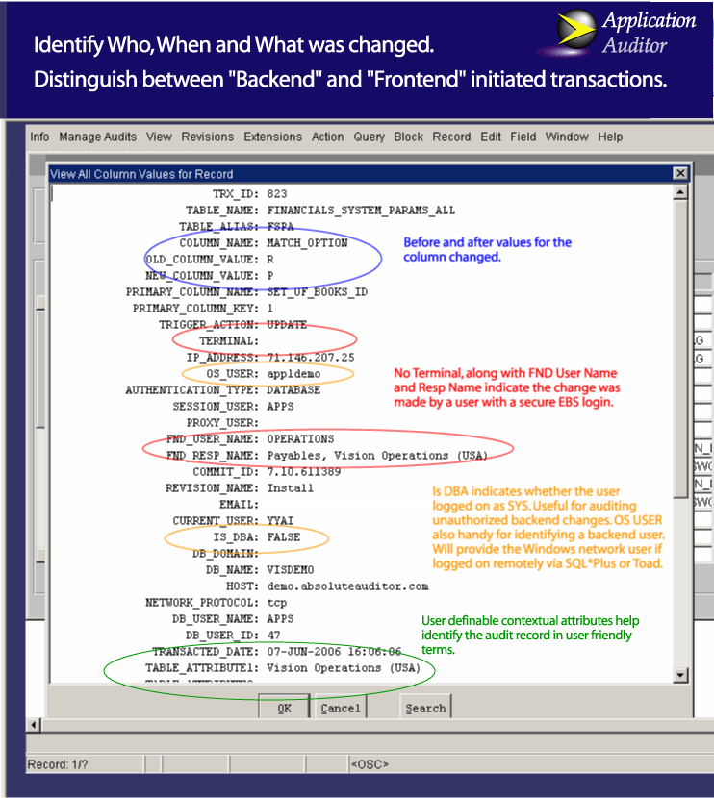

Application Auditor Example

**Product Description**



**SOD Violations Manager** enables Internal Audit and Finance Staff to establish Segregation of Duties policies, deploy them into the Oracle E‑Business Suite environment, and enforce them.

***SOD Violations Manager***

# Product Summary

**Key Functionality**

* Standard online E-Business Suite reporting:
  + User Access Hierarchy
  + Defined Function Conflicts, including User exemptions
  + Function Assignment Conflicts by User
  + Function Assignment Conflicts Matrix
  + Function Assignment Conflicts Menu Summary
* Reporting uses parameters such as:
  + Revision, which defines SOD conflict definition sets
  + Real time in EBS or snapshot
  + Risk levels
  + Users, Operating Units, and Responsibilities
  + Inter- and Intra-Responsibility Conflicts
  + Exclusions, Grants, and Query Only
  + Main Menu Names
* Single, flexible online form to define SOD conflicts in the E-Business Suite.
* Easy to use. You can create an SOD conflict definition in minutes, and immediately query the E-Business Suite for Users with violations.
* SOD conflict definitions draw on the functions currently in your E-Business Suite environment.
* Reporting is based on actual active Users, Responsibilities, Menus and other access variations in the EBS instance.
* Violation data can be loaded directly into Microsoft Excel via direct connection to the E-Business Suite database for ad hoc analysis using the tool Finance and Audit Staff are familiar with.

**Optional Modules**

* SOD Violations Manager’s seeded SOD conflict list.
* Customers can load their own SOD conflict lists, if available, without need to use the built-in list from Absolute Technologies.

**Distinguishing Functionality**

* Over a thousand SOD conflict definitions for both E-Business Suite 11i and R12.
* Two major E-Business Suite hosting service providers have approved SOD Violations Manager. Installation and operations meet their standards for reliability without impacting E-Business Suite uptime for their customers.
* SOD Violations Manager provides a transparent environment that documents SOD policies and facilitates working with external auditors. If there are disagreements, once the policy or EBS-related decisions have been made, it is a trivial task to adjust SOD VM’s conflict definitions.
* SOD VM shares the database instance with your Oracle E-Business Suite application. As a result, you are not required to manage, monitor or purchase another server or database instance.
* Built with Oracle development tools, with a familiar user interface.
* The revision control architecture enables you to modify a set of SOD conflict definitions and create variations of Revision sets for flexible and varied reporting.
* The migration utility enables you to copy SOD conflict definitions between your development, test, and production systems with total accuracy.
* Startup services are available if needed, to analyze your SOD requirements and policies, map them to SOD VM’s seeded conflict list, perform baseline reporting, and plan a project to eliminate the violations.

**Conclusions**

SOD Violations Manager’s functionality and seeded content simplify SOD controls within E-Business Suite environments. Finance and Internal Audit Staff can put controls in place on their terms, not technical ones. They are less dependent on IT Staff to evaluate the Responsibility, Menu, and Sub-Menu structures the IT Staff themselves develop and support. This is good for IT because it reduces the workload to support SOD controls audits.

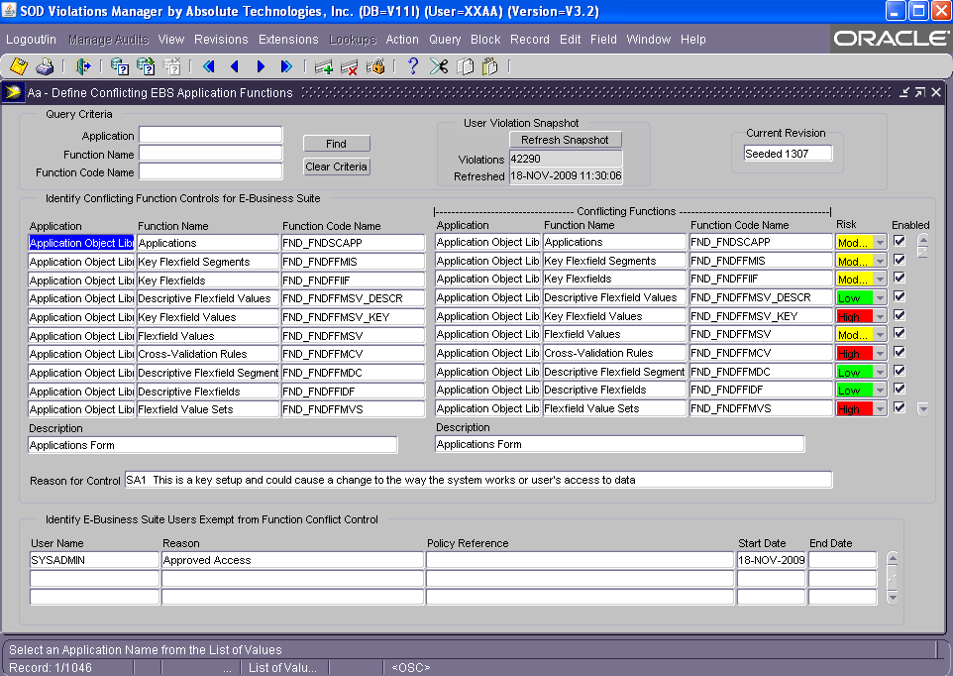

Define SOD Conflicts

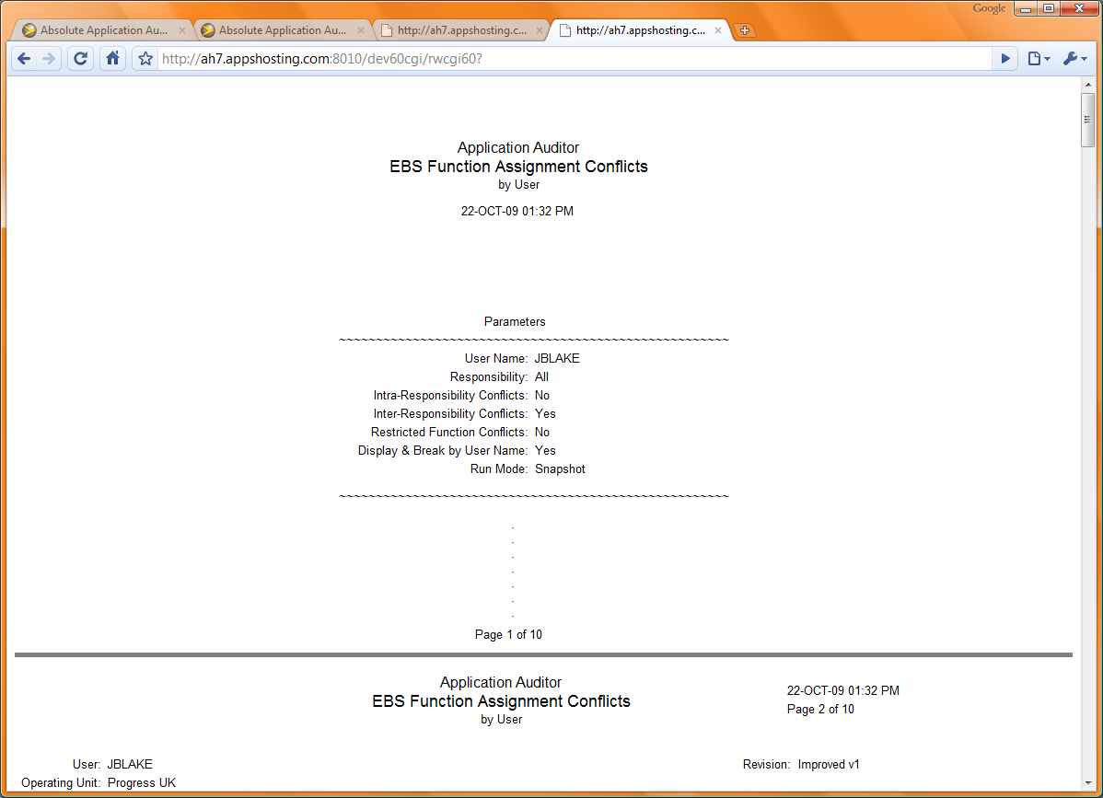

EBS Function Assignment Conflicts Report Parameters

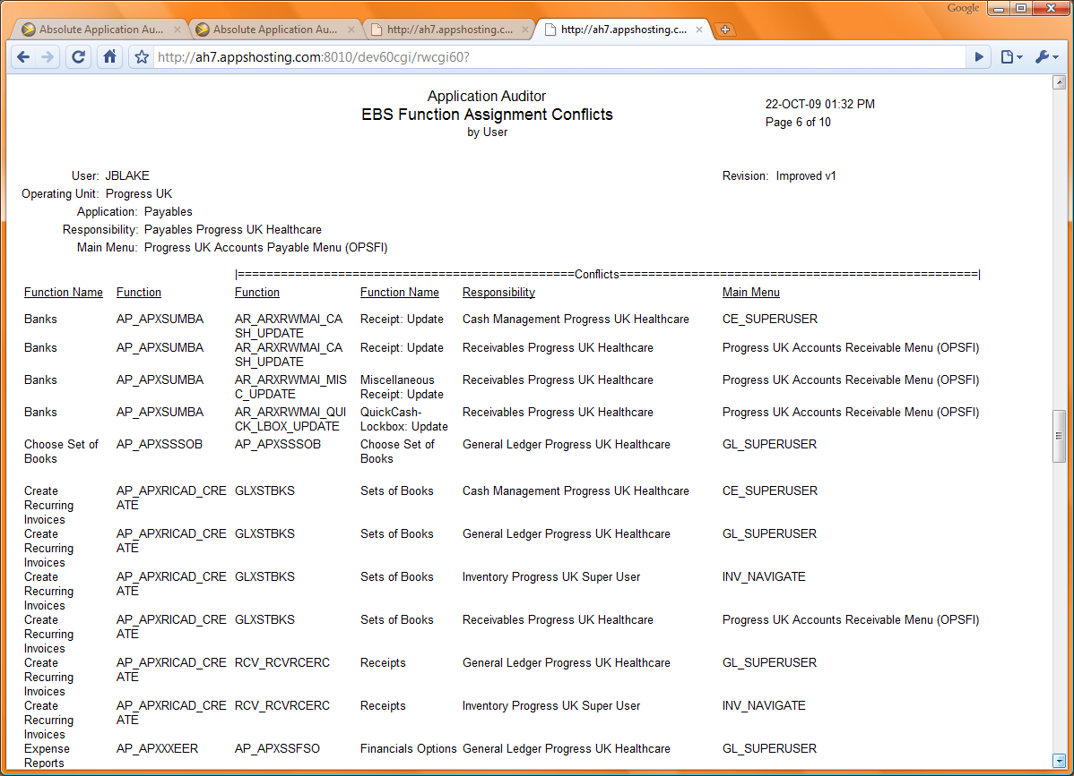

EBS Function Assignment Conflicts Report

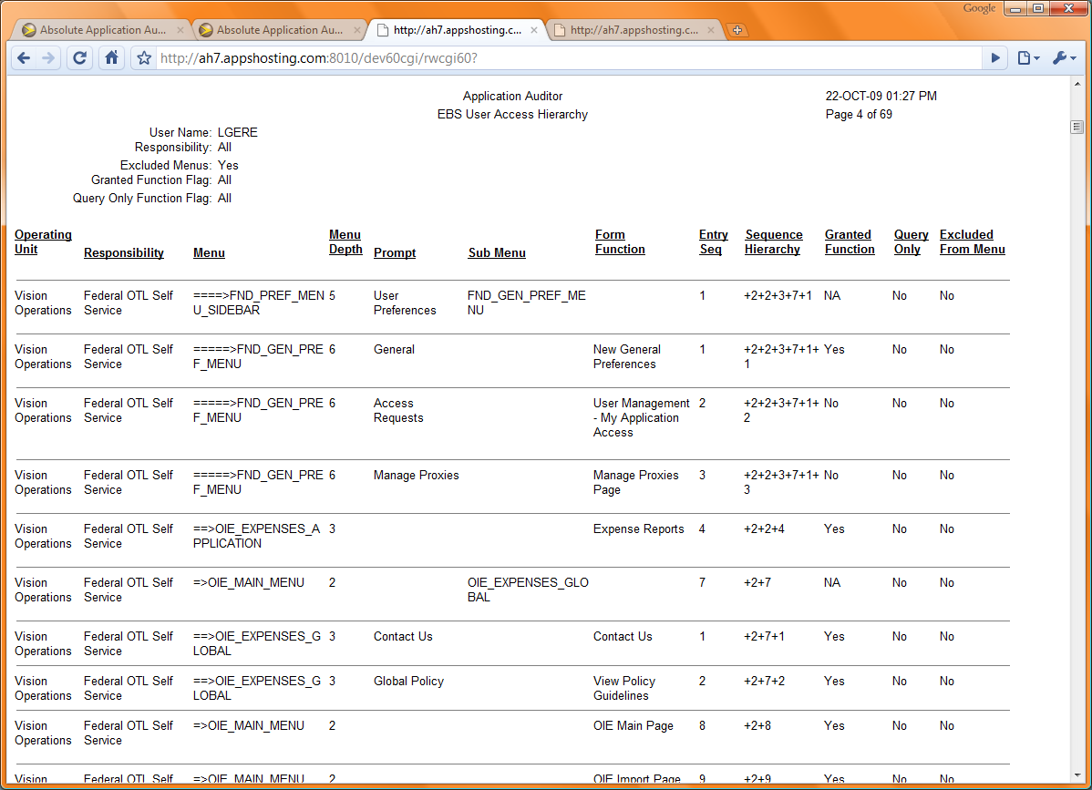

EBS User Access Hierarchy

Absolute Technologies, Inc. helps companies leverage their Oracle Applications investment through its line of products and solutions. Absolute provides software, professional services and support to assist customers with critical business functionality in particular under-developed areas of the Oracle Applications domain.

Founded in 1997, Absolute's commitment to affordable and innovative solutions for Oracle Applications customers is one of the main reasons why our customer base continues to expand year after year. Absolute solutions accommodate virtually any size company utilizing Oracle Applications. Our customers represent businesses in Manufacturing, Financial, Distribution, High-Tech and Internet industries.

© 2010 Absolute Technologies, Inc. All rights reserved.

Visit these links for more information.

Absolute Technologies, Inc. helps companies leverage their Oracle Applications investment through its line of products and solutions. Absolute provides software, professional services and support to assist customers with critical business functionality in particular under-developed areas of the Oracle Applications domain.

Founded in 1997, Absolute's commitment to affordable and innovative solutions for Oracle Applications customers is one of the main reasons why our customer base continues to expand year after year. Absolute solutions accommodate virtually any size company utilizing Oracle Applications. Our customers represent businesses in Manufacturing, Financial, Distribution, High-Tech and Internet industries.

© 2010 Absolute Technologies, Inc. All rights reserved.

Application Auditor   
 <http://www.absolute-tech.com/products/aa.htm>

SOD Violations Manager   
 <http://www.absolute-tech.com/products/sod_vm.htm>

Continuous SOD Management in Six Simple Steps  
 <http://www.absolute-tech.com/products/sod.htm>

Frequently Asked Questions about AA and SOD VM  
 <http://www.absolute-tech.com/download/Absolute_Tech_AA_FAQ.pdf>

SOX Controls Case Study   
 <http://www.absolute-tech.com/download/Absolute_CS_IT_Access.pdf>

Register for Mailing List  
 <http://www.absolute-tech.com/register.htm>